Wireshark Lab 6-2

202022300317 杨业昶

## Step 1: Capture a Trace

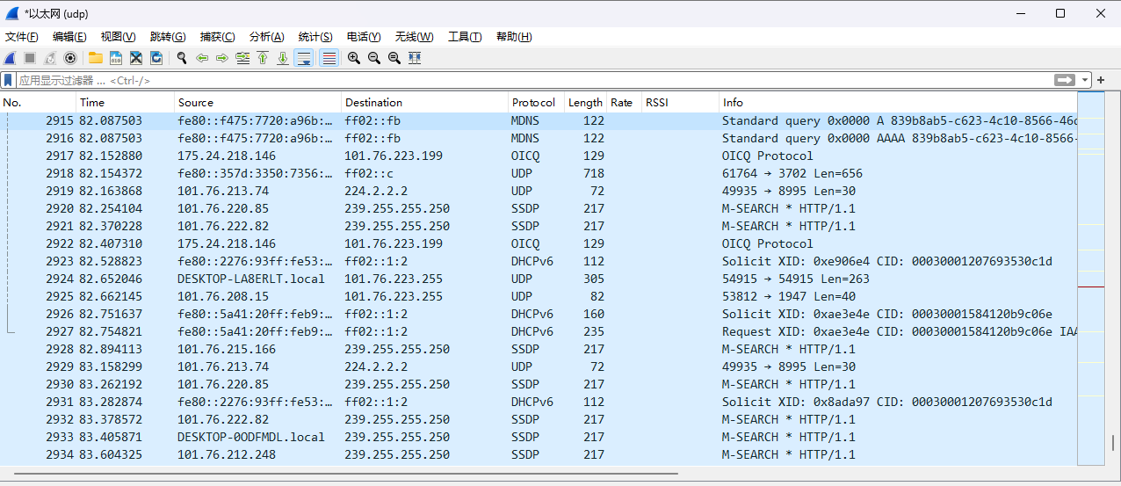

## Step 2: Inspect the Trace

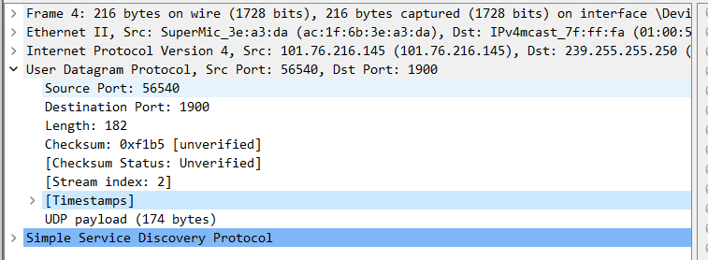

## Step 3: UDP Message Structure

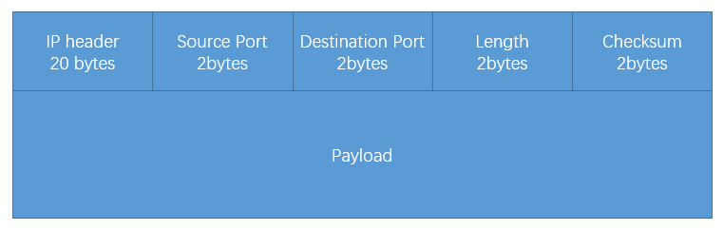

What does the Length field include? The UDP payload, UDP payload and UDP header, or UDP payload, UDP header, and lower layer headers?

>>> UDP Header + UDP Payload

How long in bits is the UDP checksum?

>>> 2bytes

How long in bytes is the entire UDP header?

>>> 8bytes

## Step 4: UDP Usage

Give the value of the IP Protocol field that identifies the upper layer protocol as UDP

>>> Protocol: UDP (17)

Examine the UDP messages and give the destination IP addresses that are used when your computer is neither the source IP address nor the destination IP address.

>>> 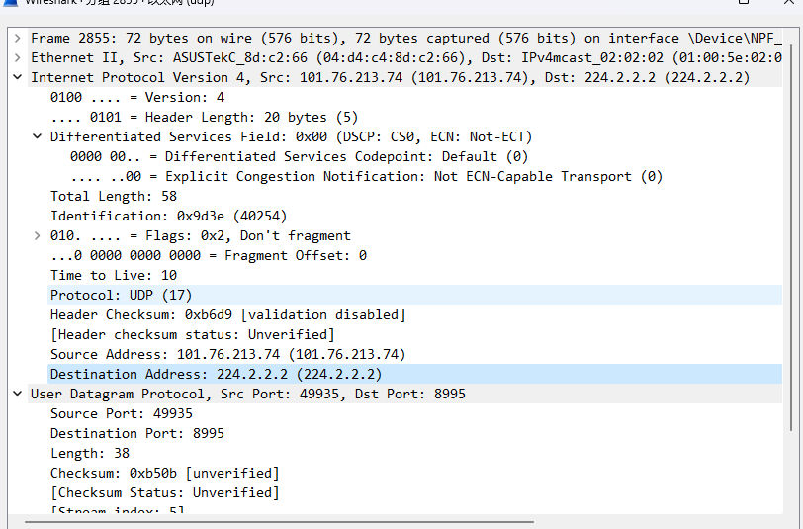

What is the typical size of UDP messages in your trace

>>> 263bytes